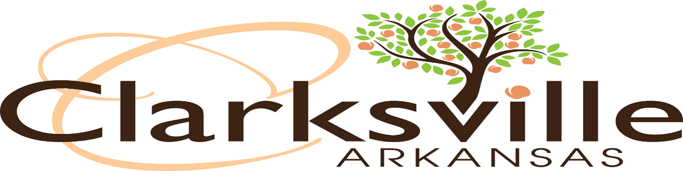

Private Club Monthly Declaration of Sales of Alcoholic Beverages
(Payable by the 20th of each month following the month of the sales)
NOTICE
Make checks payable to:
City of Clarksville
Mail to:
City of Clarksville
205 Walnut Street
Clarksville, AR 72830
RETURN THIS COPY FOR PROPER CREDIT
For the Month ____________________________________________
Business Name____________________________________________
Owner’s/Corporation Name_________________________________
Physical Address __________________________________________
________________________________________________________________________________________________________
Computation of Tax
1. Gross Receipts of Sales of Beer, Wine and Mixed Drinks: $__________________
2. Tax Due (5% of Gross Receipts in line 1): $__________________
3. Gross Receipts of Mixed Drinks Only: $__________________
4. Tax Due (2% of Gross Receipts in line 3): $__________________
5. Total Tax Due (Line 2 plus Line 4): $__________________
6. Penalty after the 20th: (10% of line 5) $__________________
7. Total Remittance (Line 5 plus Line 6) $__________________
A completed copy of the Arkansas Excise Tax Report for the same month as this report must be attached to the report.
I hereby state, avow and affirm that the statements contained herein are full, true, and correct. I also agree that the total taxable receipts shown on this report agree with the total amount reported to the State of Arkansas Department of Finance. Date Prepared_____________________________________
Signature of Owner, Officer or Authorized Agent____________________________________________
Print Name and Title:________________________________ Phone:____________________________

